COMPUTER SCIENCE

COURSE CODE: CSE2015

Source code Management

Handled by: Dr. Monit Kapoor

Amity university

Bengaluru

Name: Dhruti Padasalgi

Enrollment number: A86605224101

Course: B.tech CSE

Sem: 2 sem

30 January 2025

Steps involved in installing Git on laptop:

Step 01:

* Open chrome/edge or any browser on your laptop and search for “progit” in it.

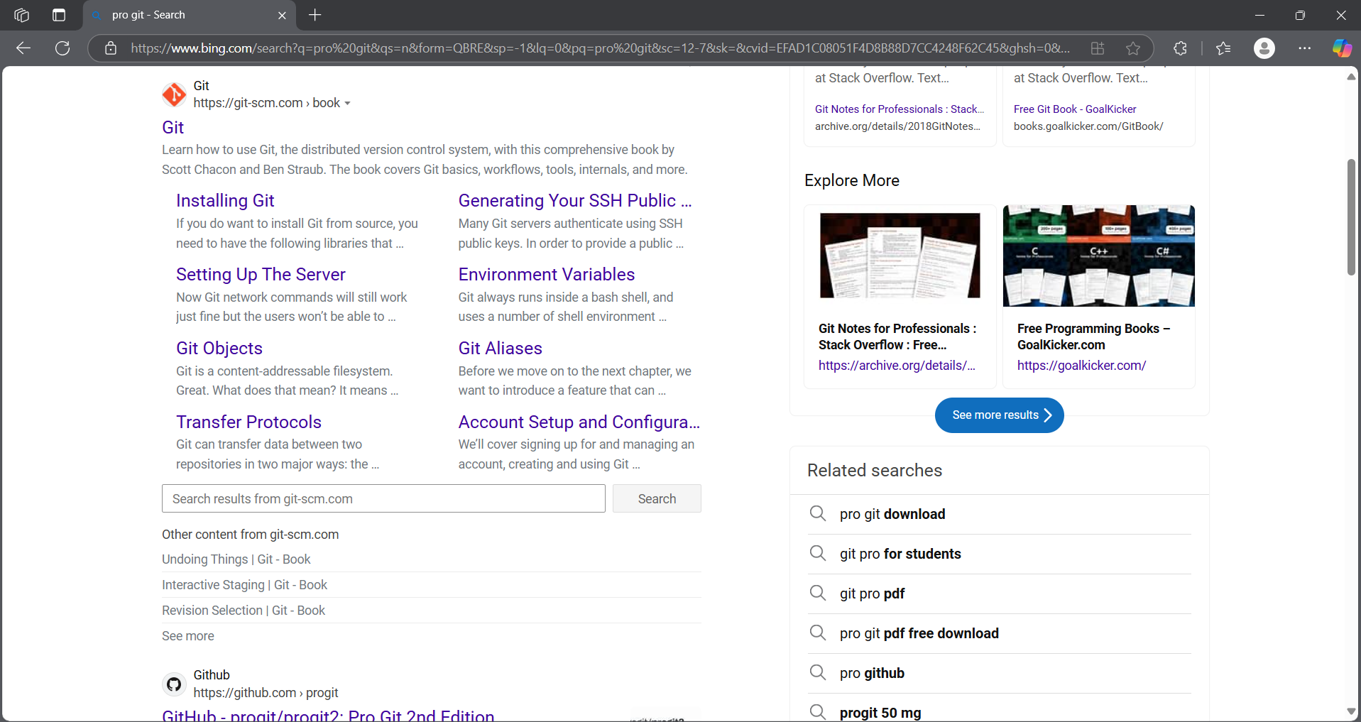

* Then click on the first web link that appears.

Step 02:

* Now click on section “1.5 installing git”.

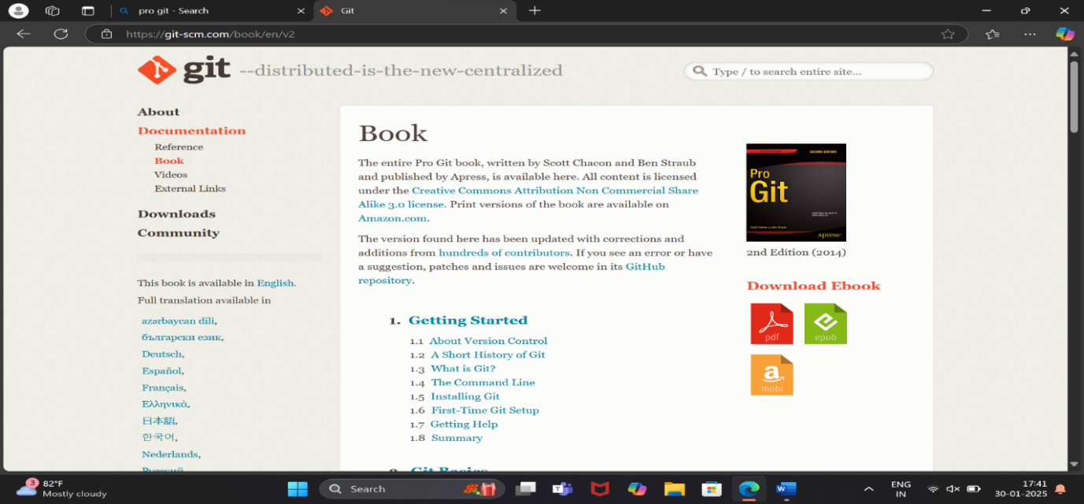

Step 03:

* Then scroll a little down and click on the link

“<https://git-scm.com/download/win>”.

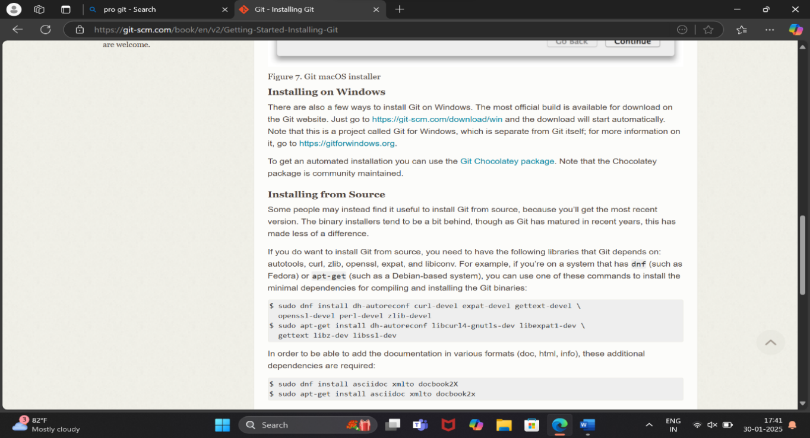

Step 04:

* Next, click on the version that you want to

download.

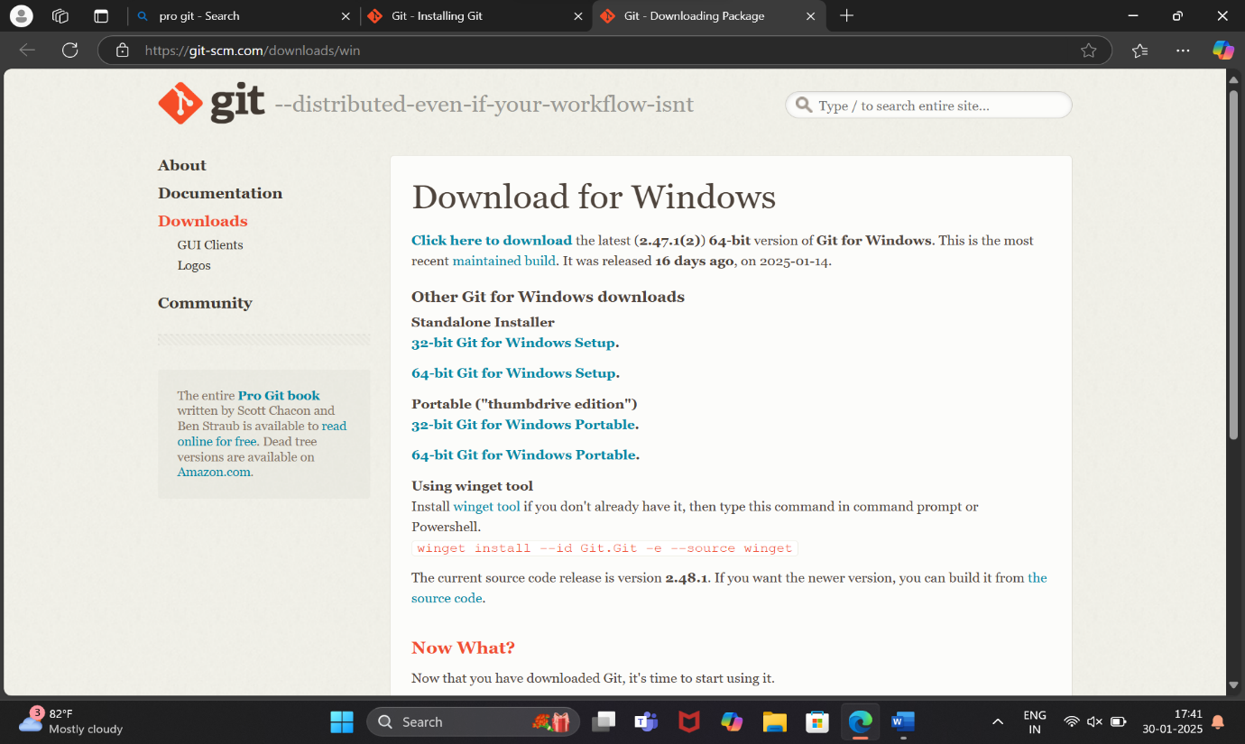

* After the download is completed, a page will show on desktop which is the general public license of git and part of git setup.

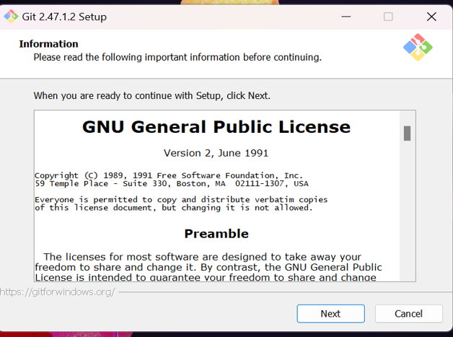

Step 05:

* Then after clicking on “next” you can choose where you want the file to be installed.

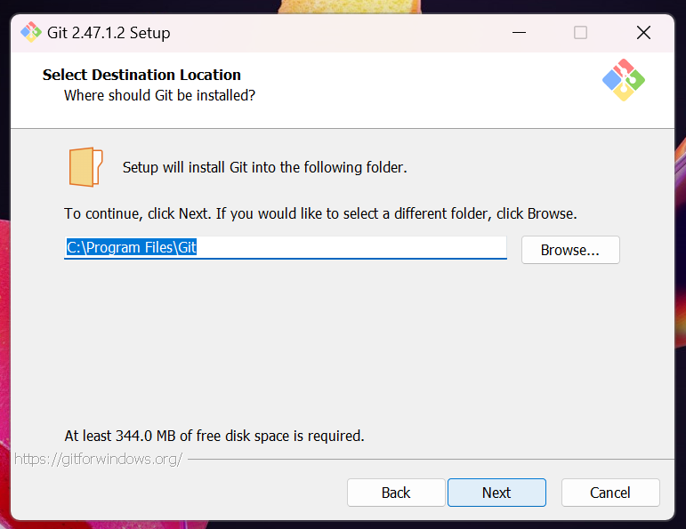

Step 06:

* After continuing from here you will be asked on which all components to install along with git.

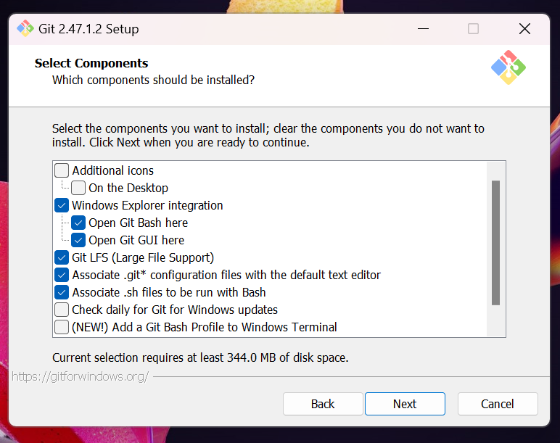

Step 07:

* After choosing them you will be asked for creating an short cut and where to save it.

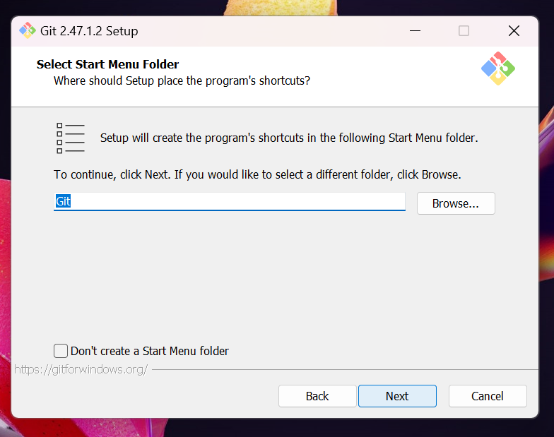

Step 08:

* Then you can choose the text editor.

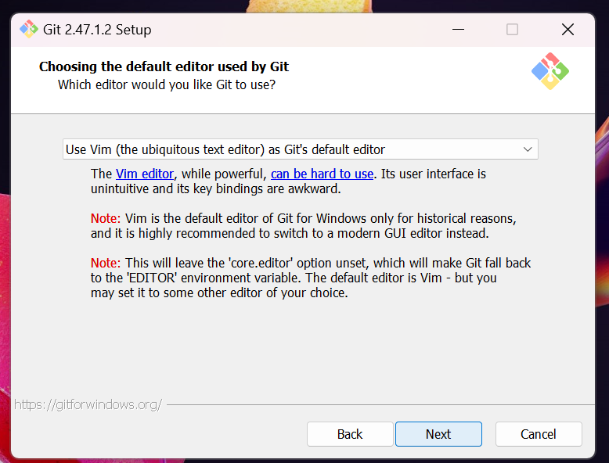

Step 09:

* Now here you can choose the initial branch name.

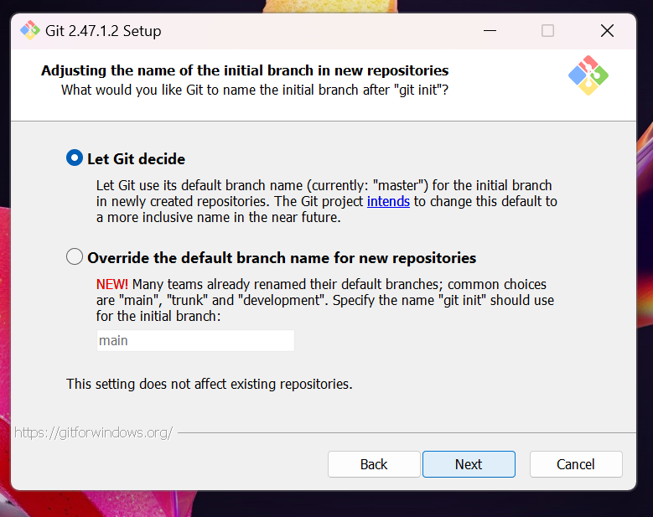

Step 10:

* Here the path is being created for git.

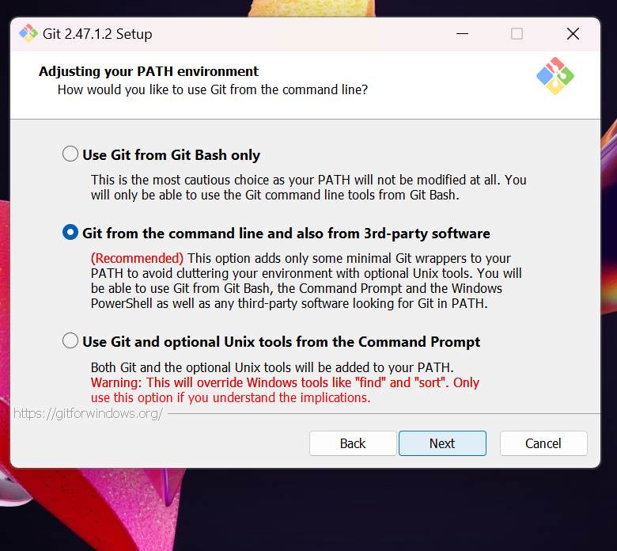

Step 11:

* Now SSH is chosen whether external or internal.

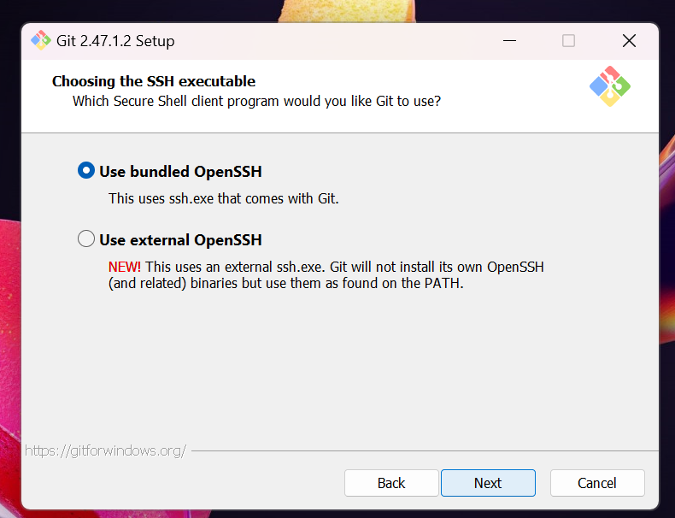

Step 12:

* Then you can choose which library can be used.

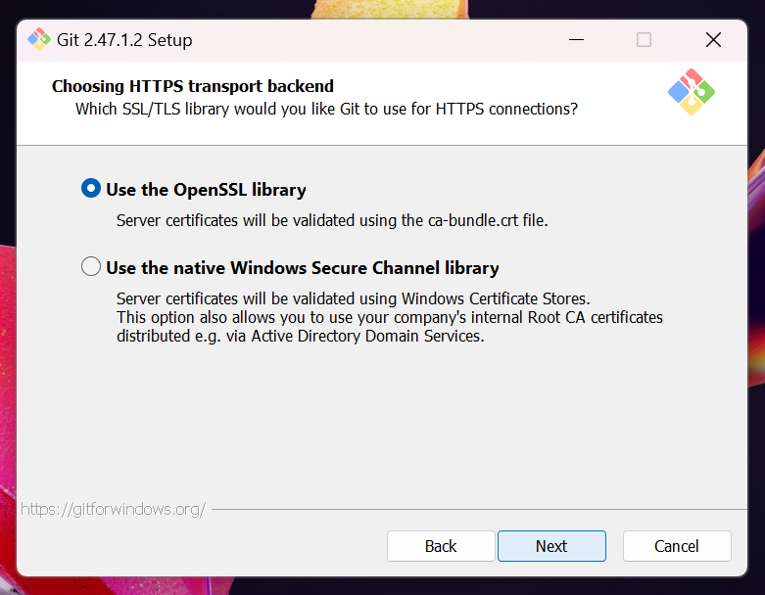

Step 13:

* Here the lines that are in text file are configured.

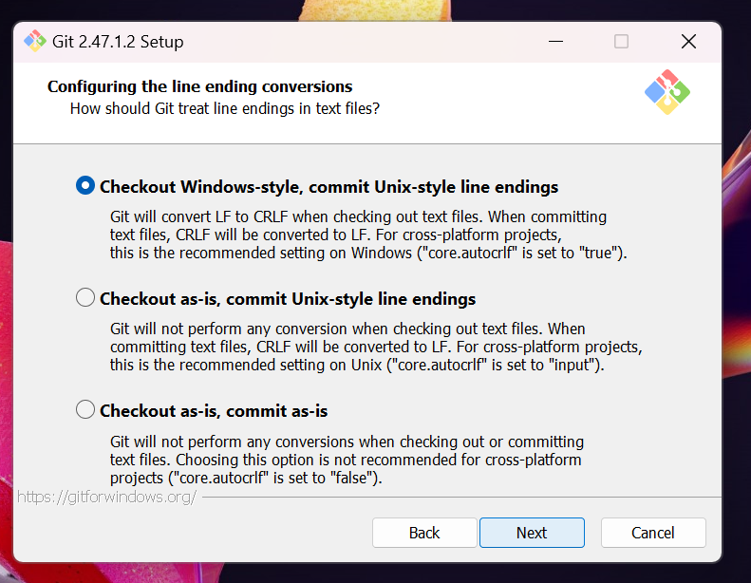

Step 14:

* You are asked to choose the terminal.

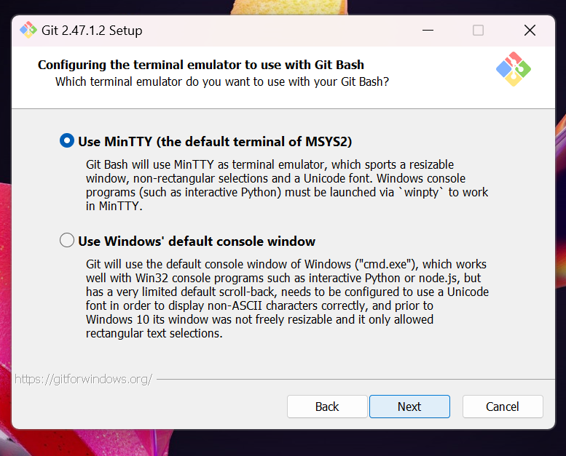

Step 15:

* Now you choose how the data is fetched from other branches.

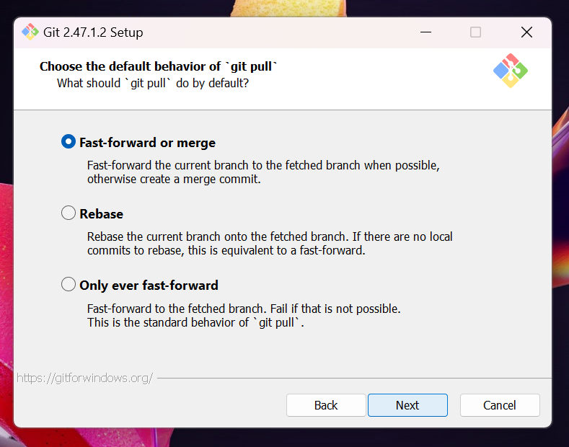

Step 16:

* Then you choose the credential manager.

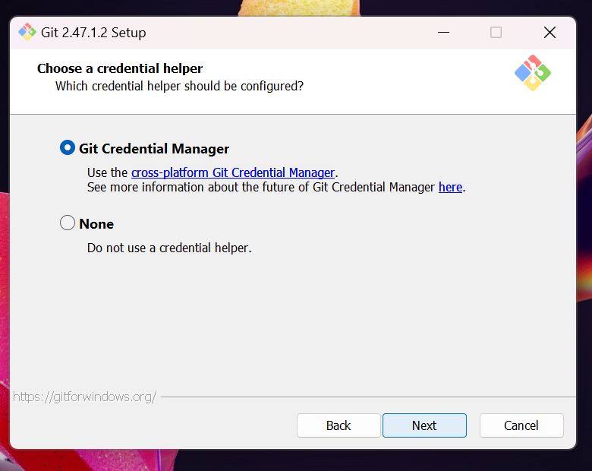

Step 17:

* Now all other features are asked to be chosen.

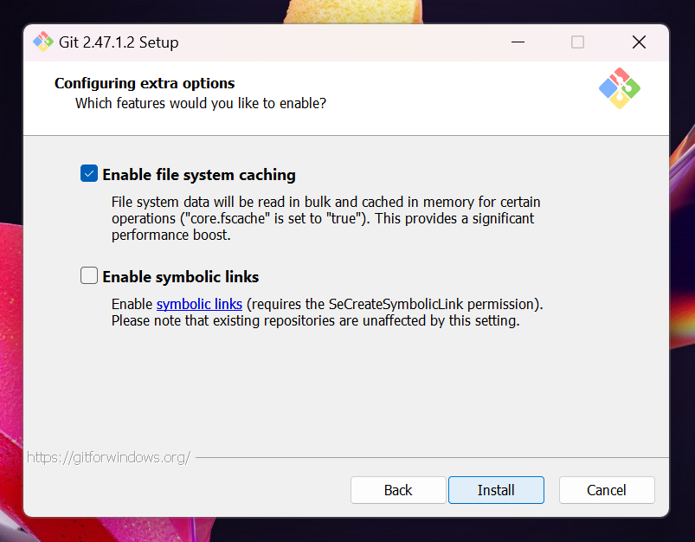

Step 18:

* Now the “Git” is being installed.

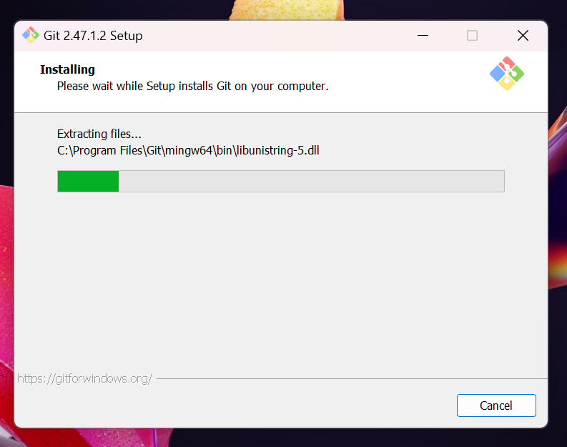

Step 19:

* Now the Git is being launched.

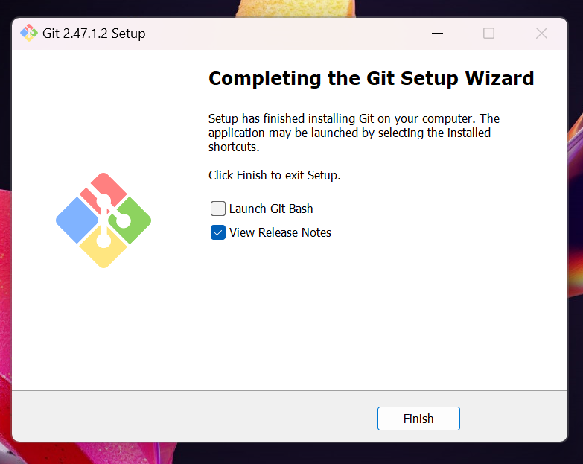

Step 20:

* Then after your taken to git tutorial page.

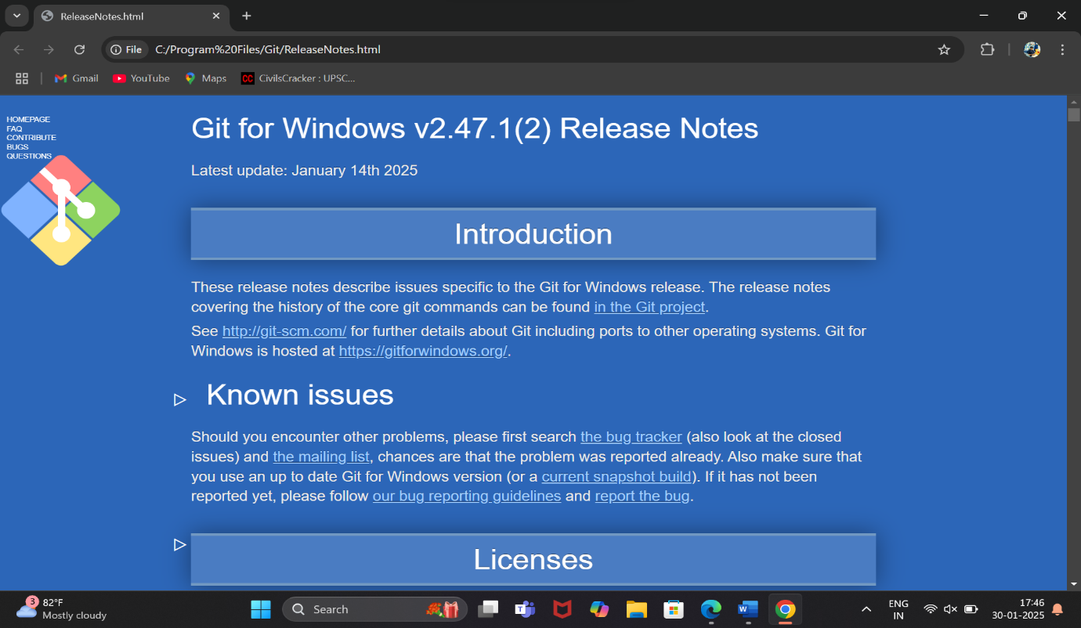

Now you can go search “Git Bash” on you’re windows.

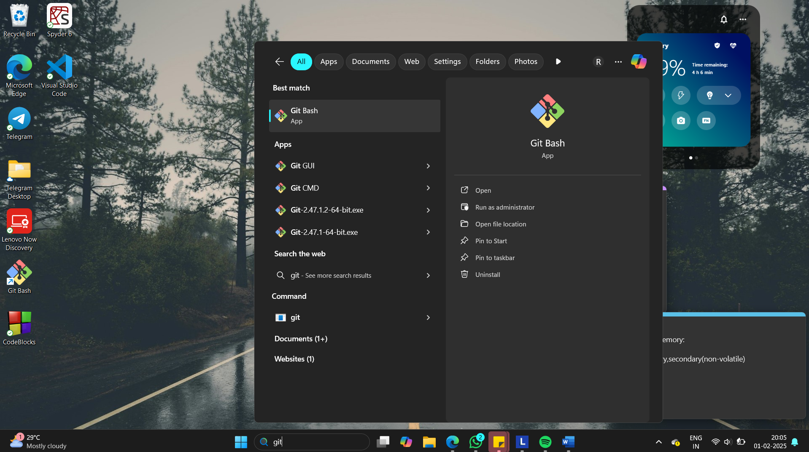

* We can type multiple command prompts to check
* ls for list of files
* date to display the date, time also can be displayed

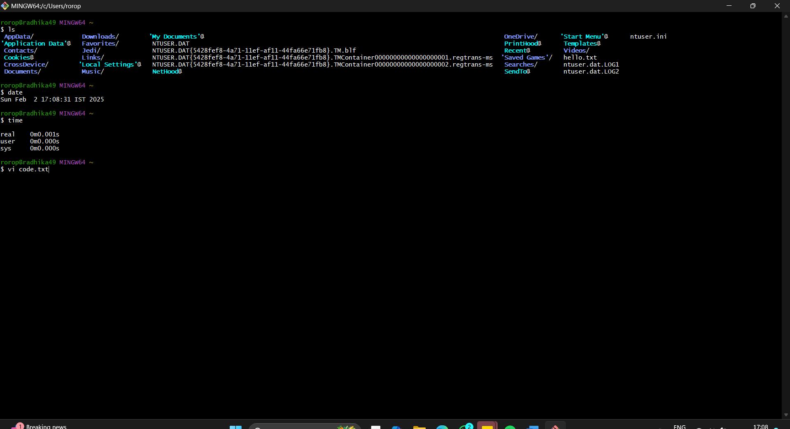

* Now, we will use a command called “vi”.

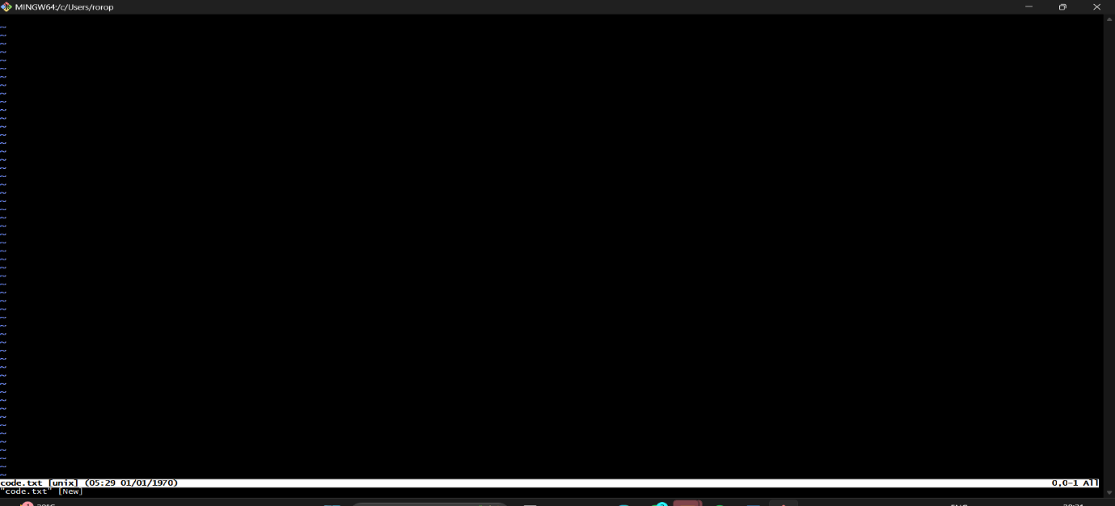

* Clicking I to insert items, then to save it we have to type ‘:wq’.

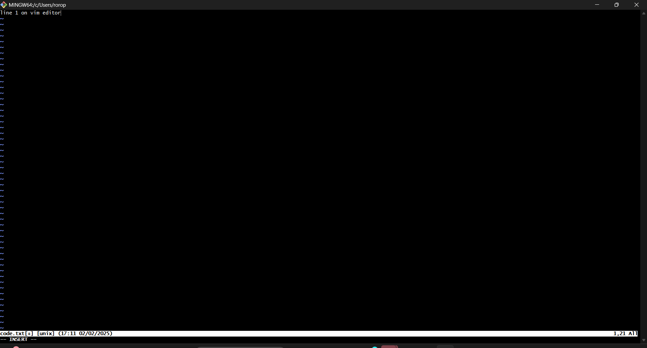

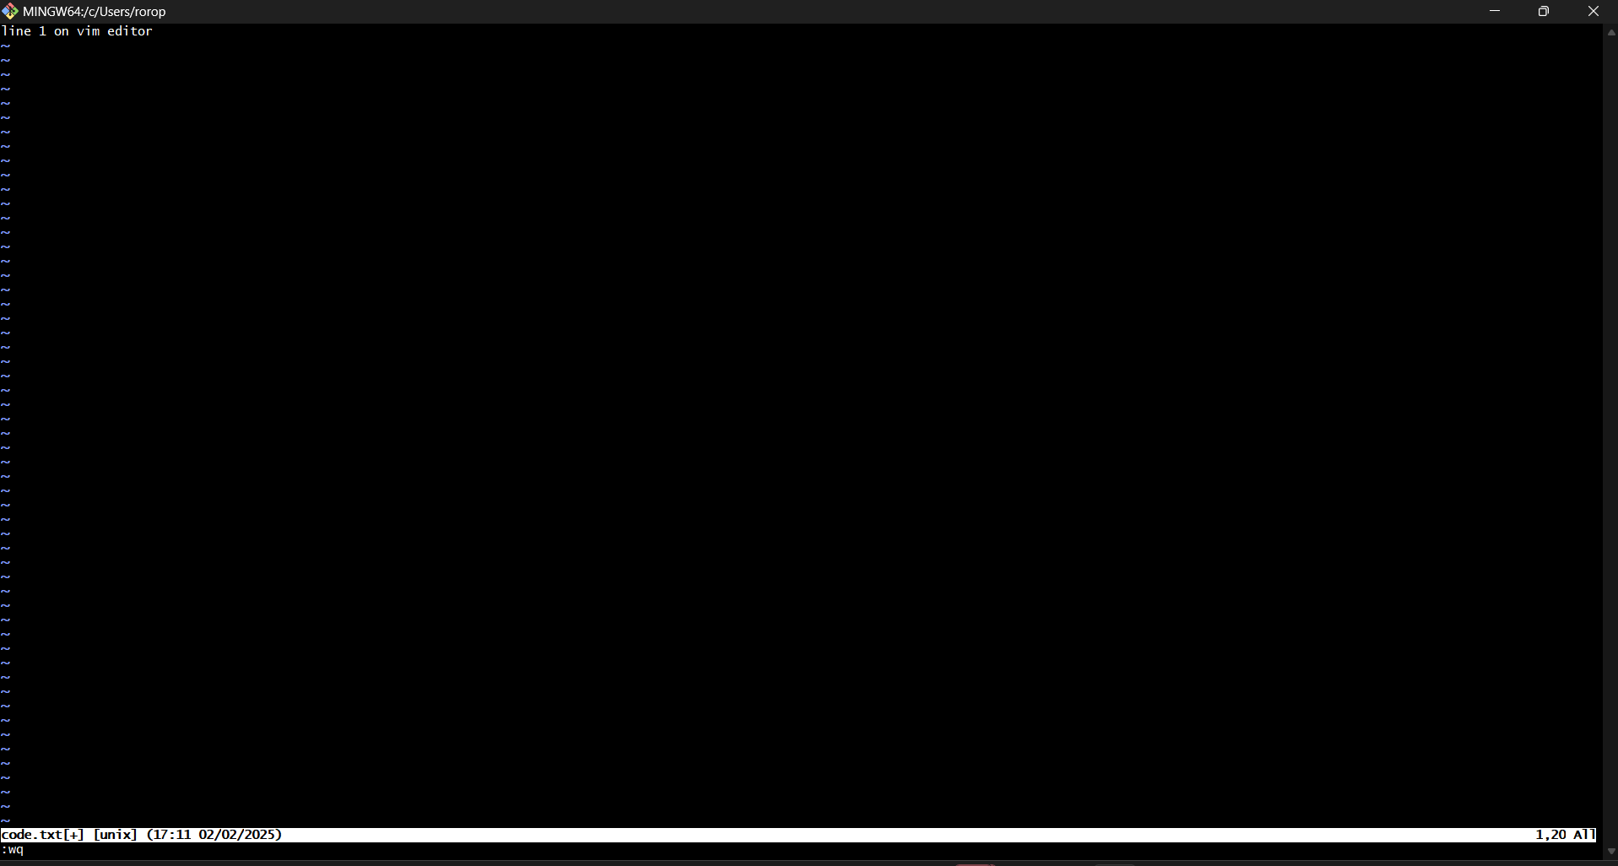

* Cat command is used to read the file

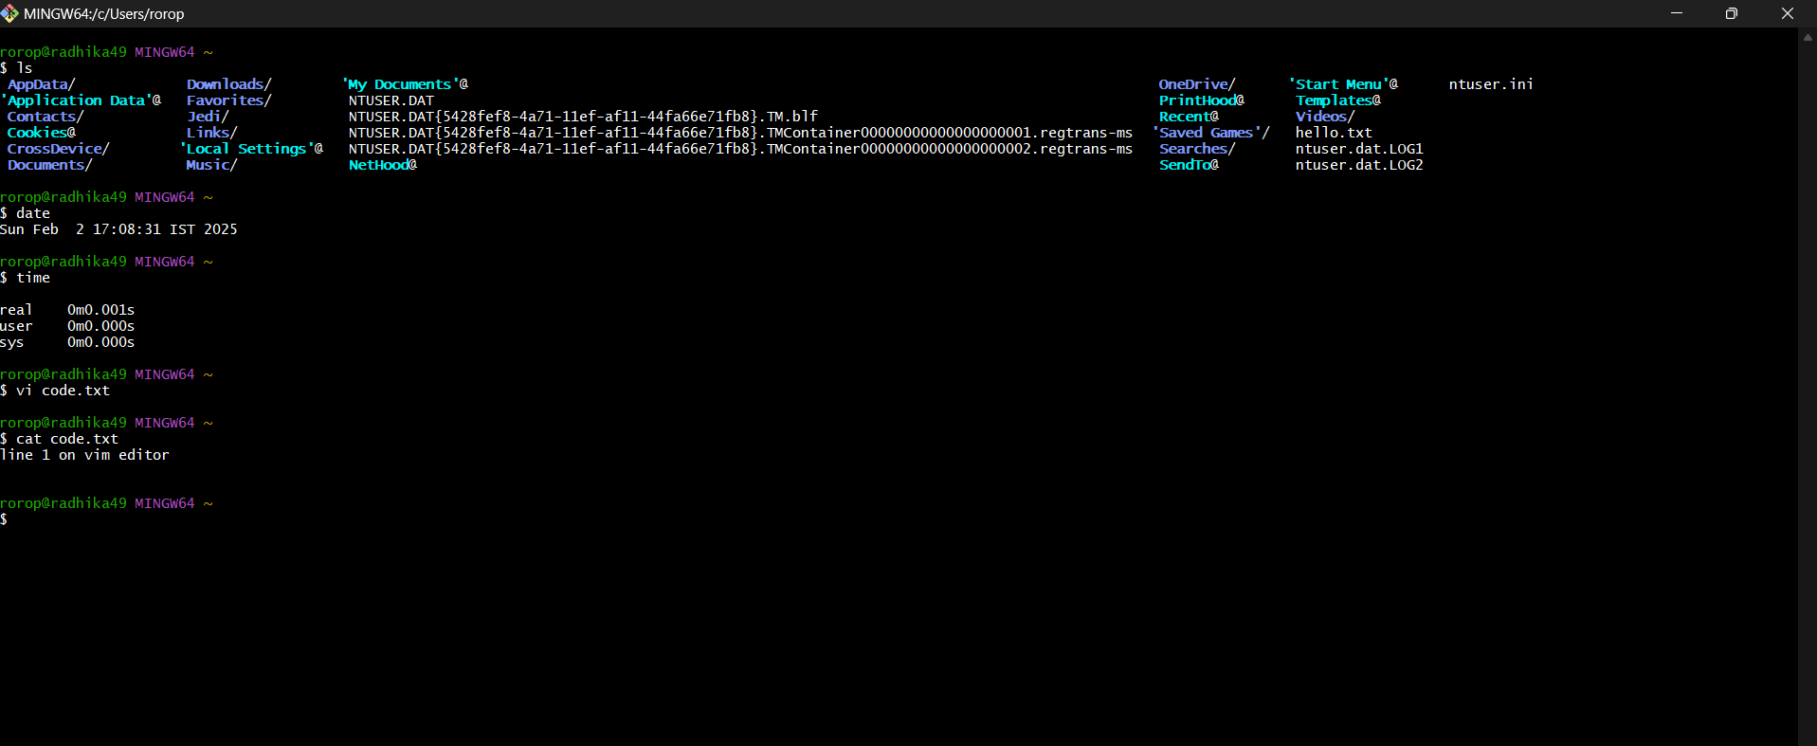

* Using different commands on the Git.
* mkdir is used to create a folder and rmdir to delete

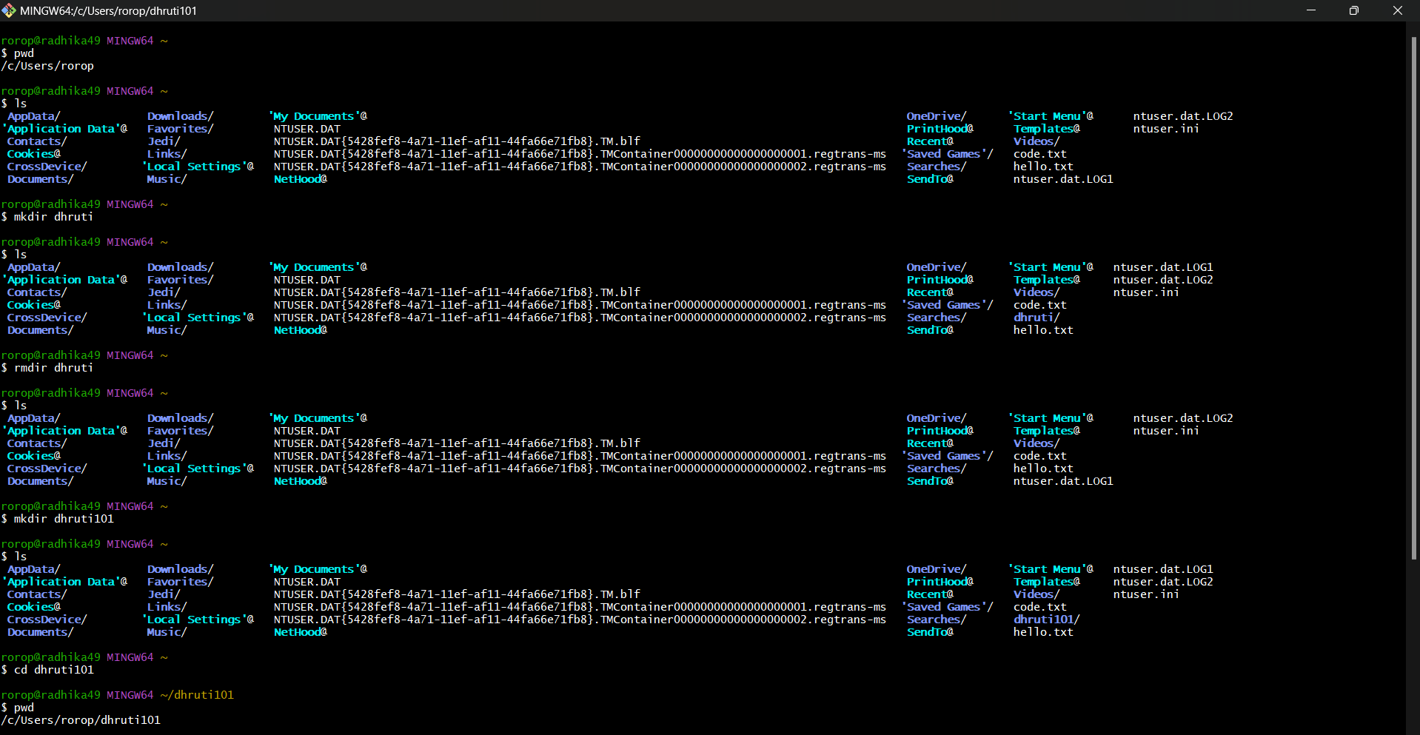

* git init is used to initialize the repository.
* git add is used to add the file in the repository.

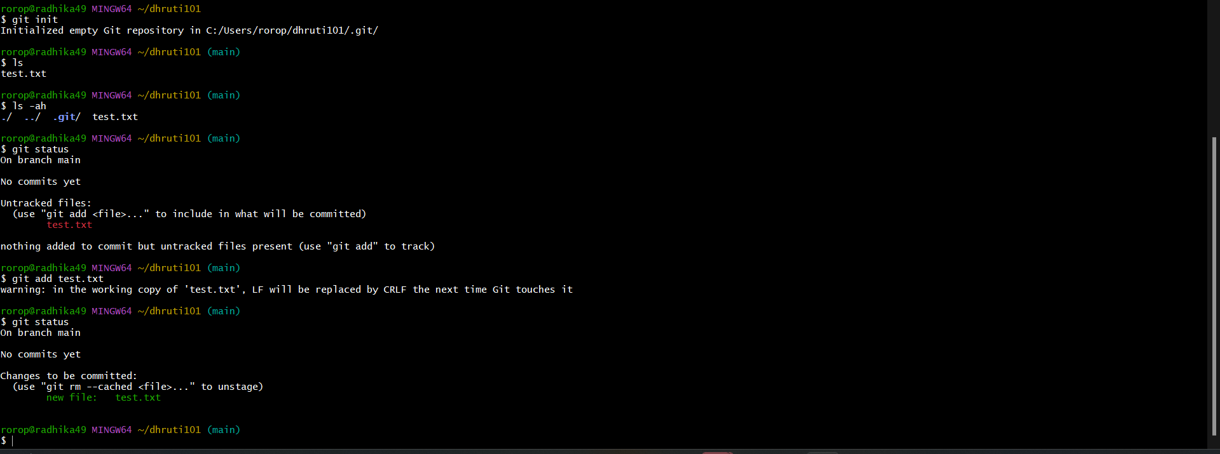

* git commit is used to write the message about the changes.

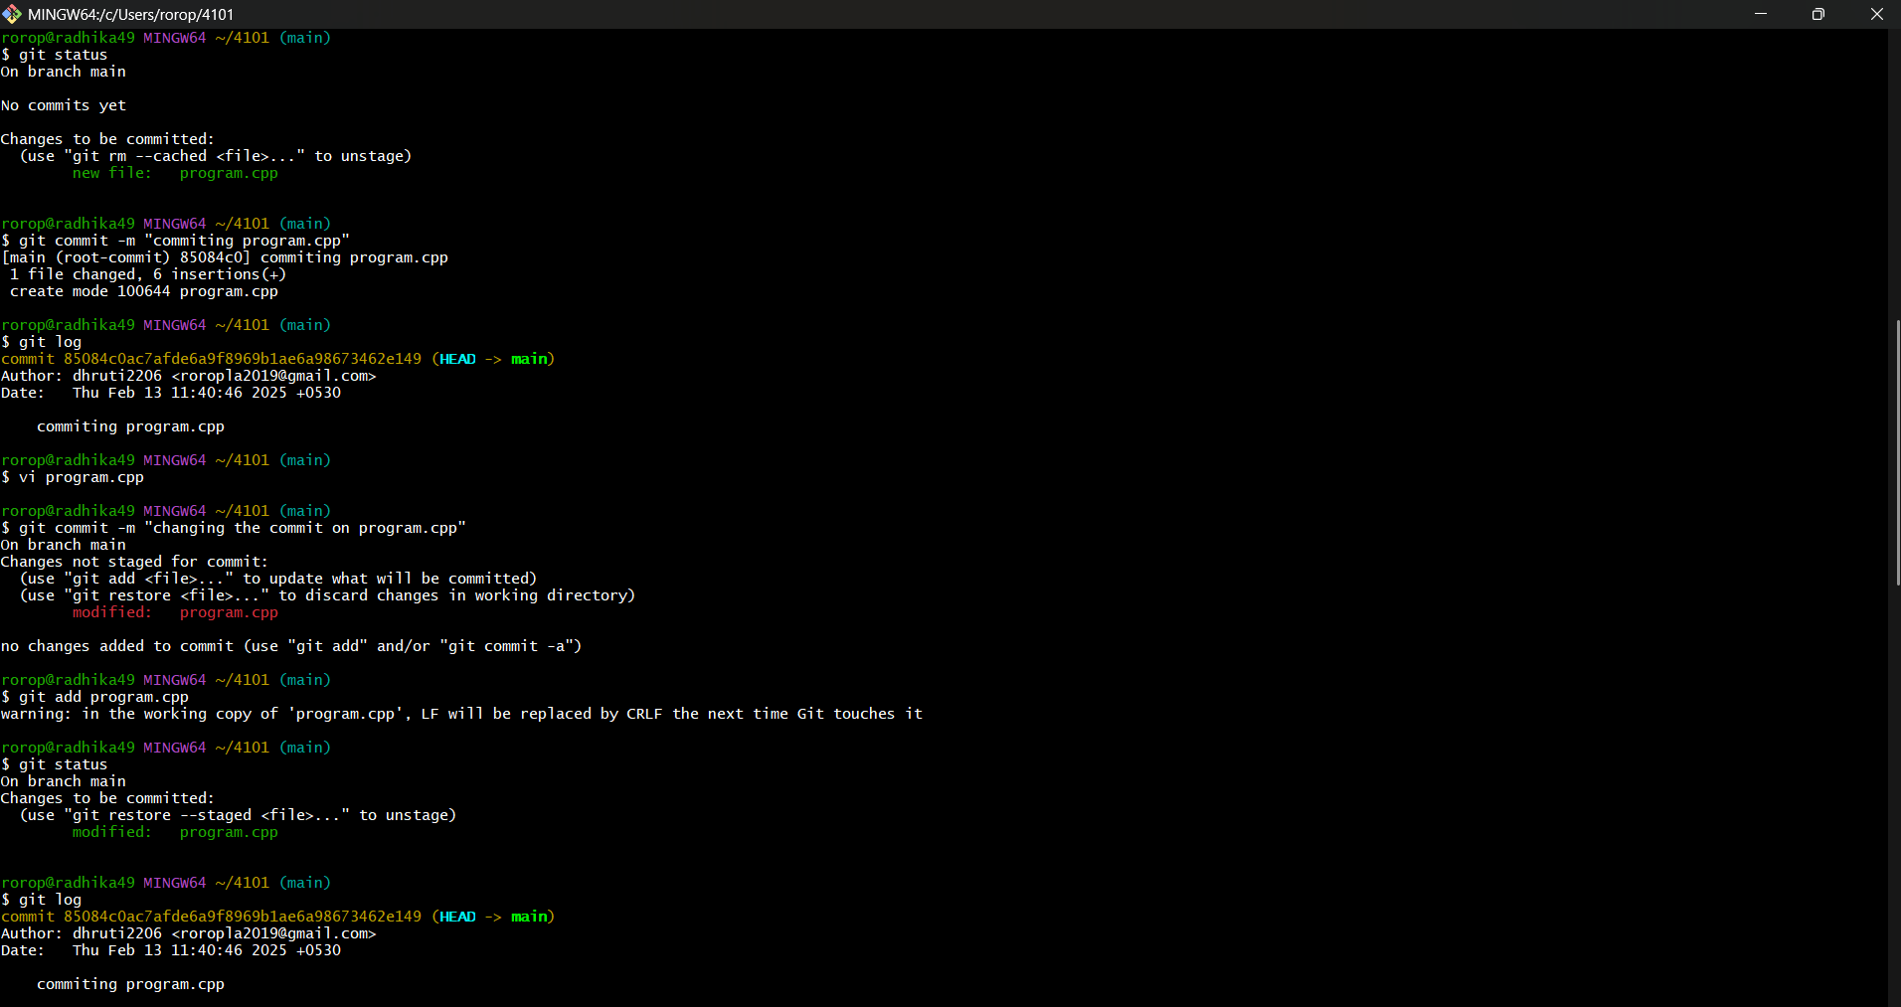

* git diff is used to see the difference in the code.

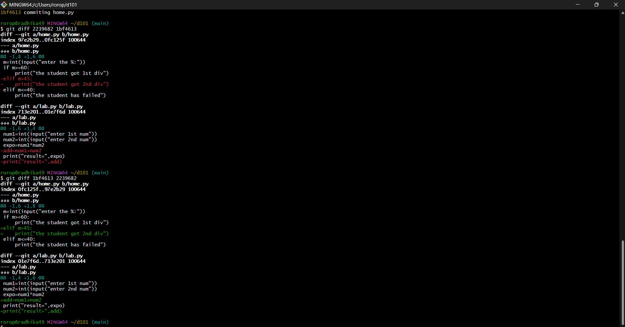

* git log --oneline is used to print a single commit in a single line as output when the git log command is executed using this option

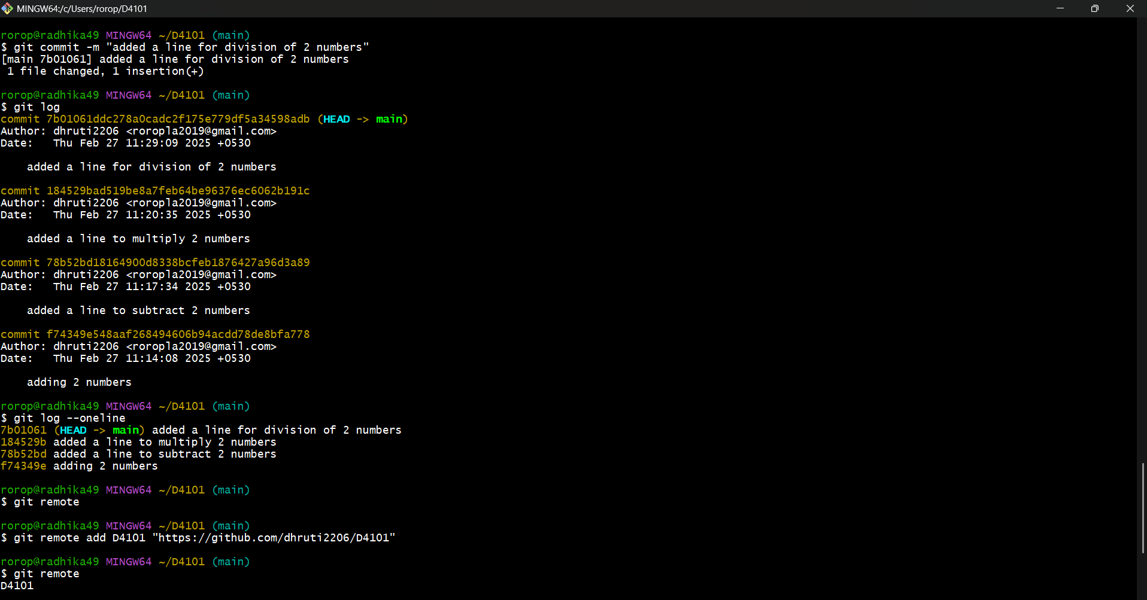

* git push is used to push the data to GitHub.

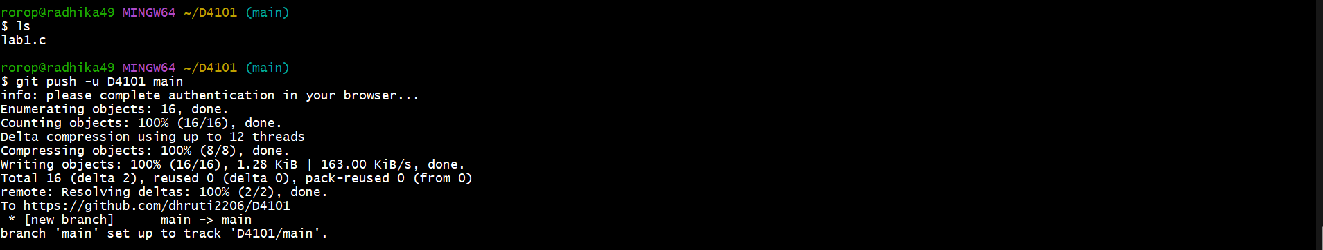

20 March 2025

Assessment 1

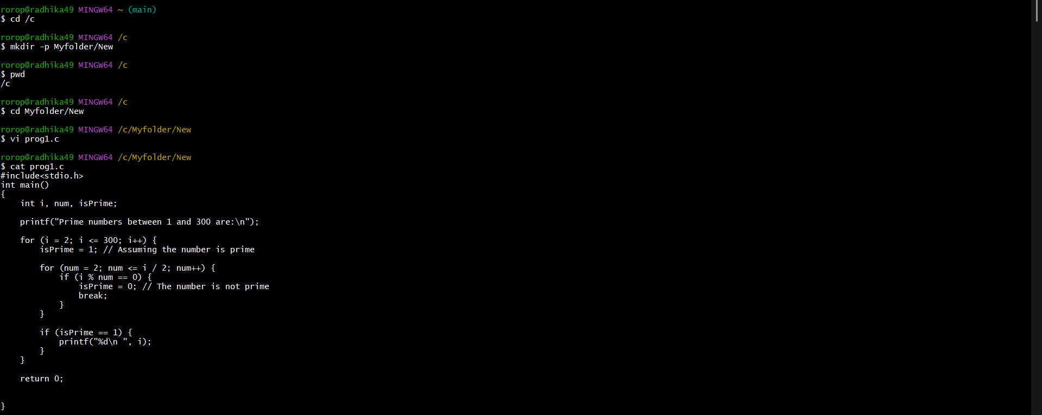

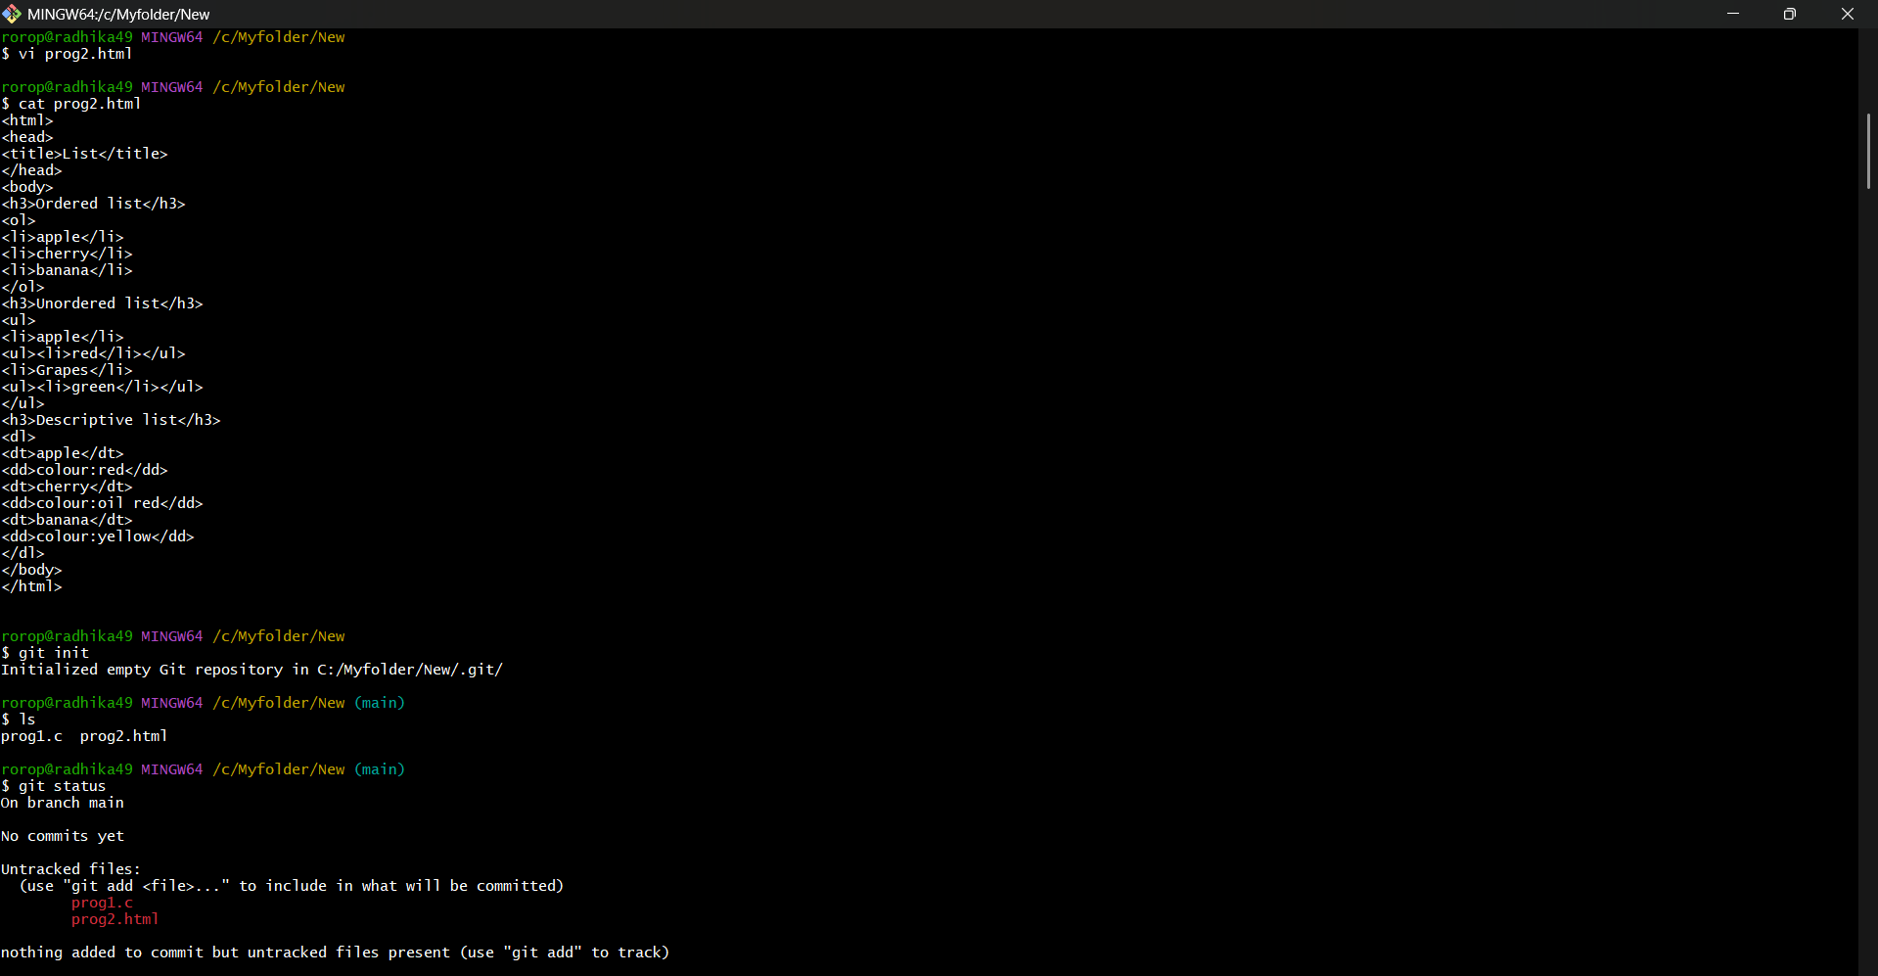

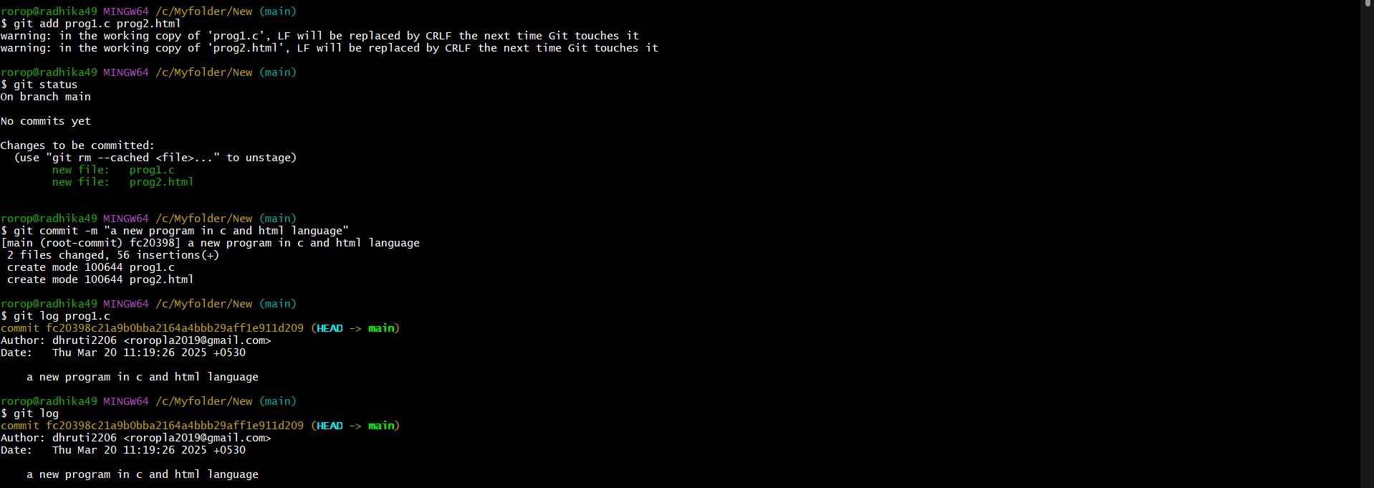

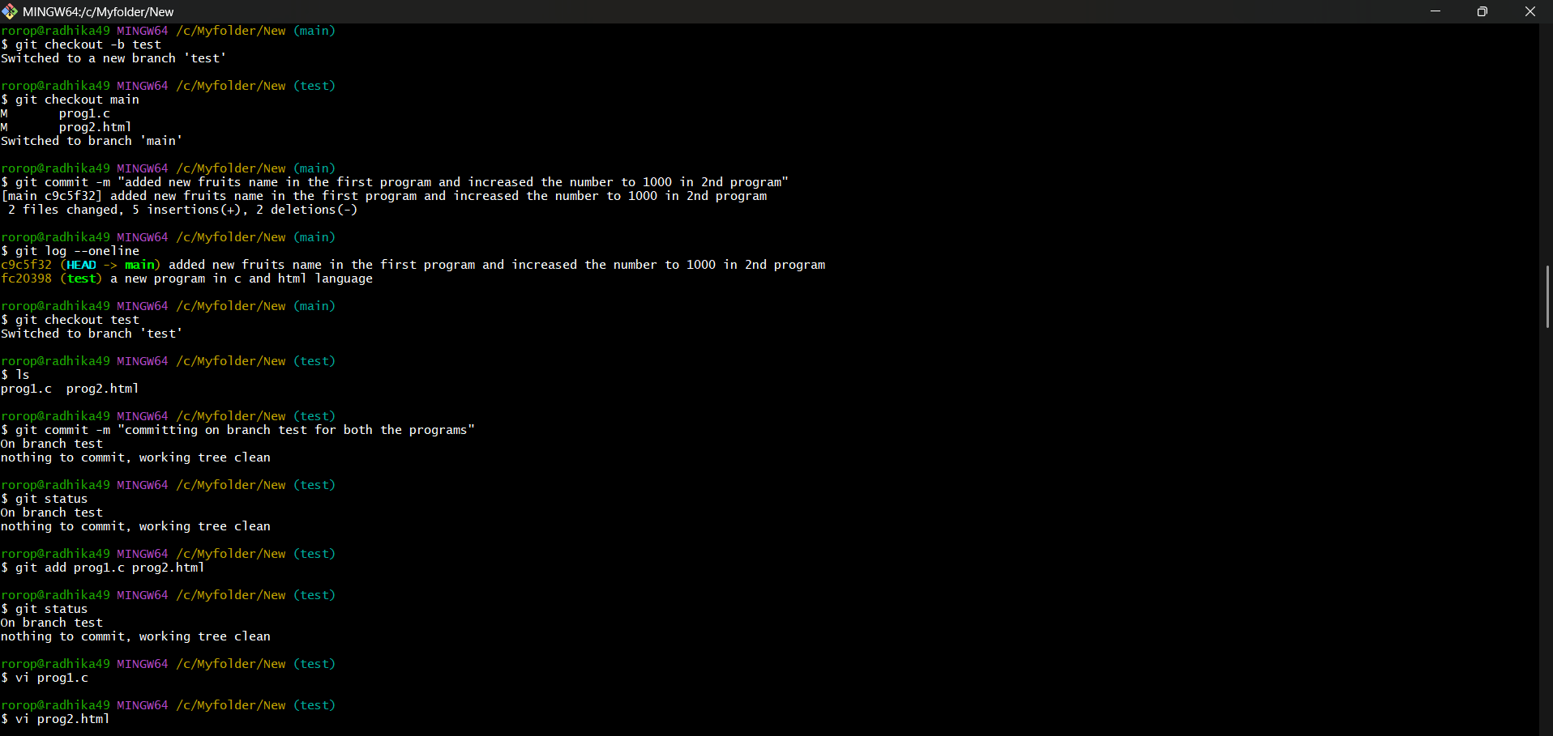

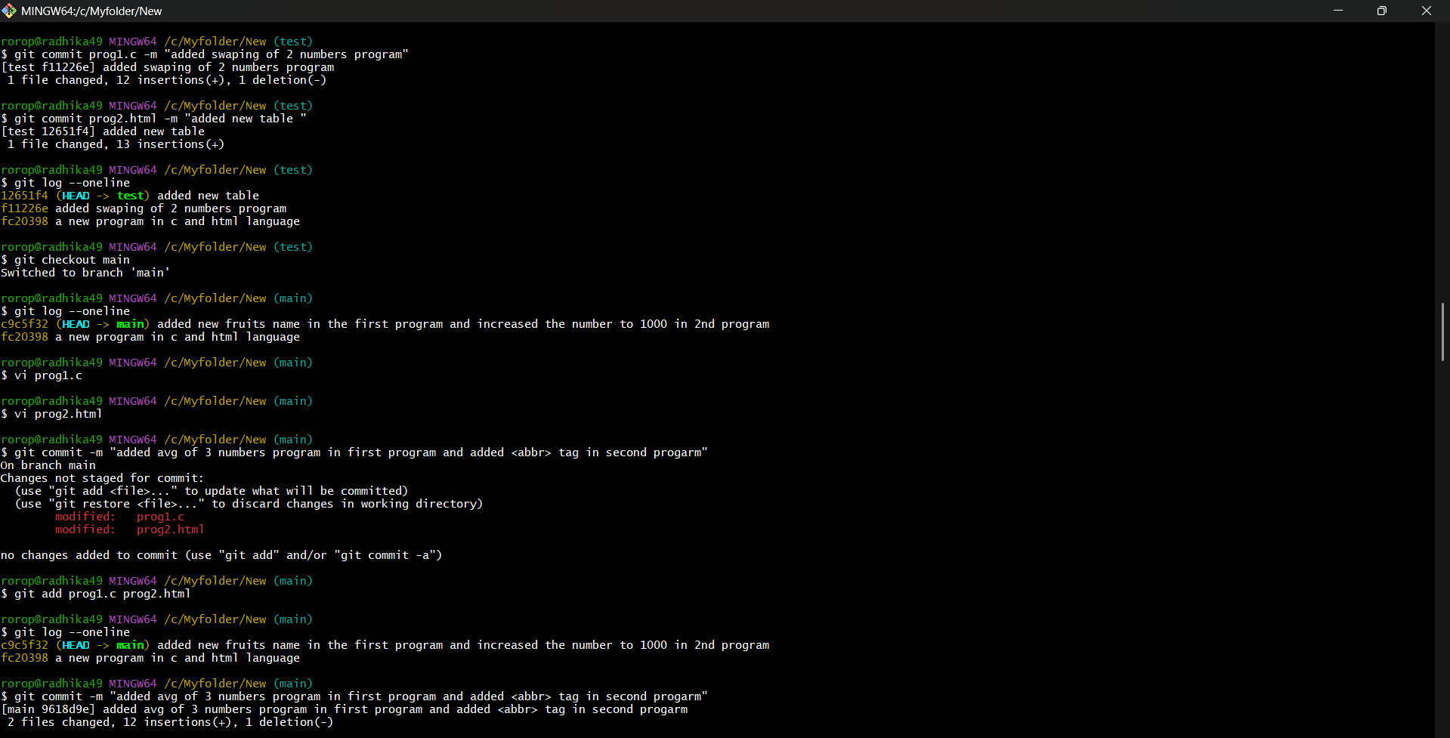



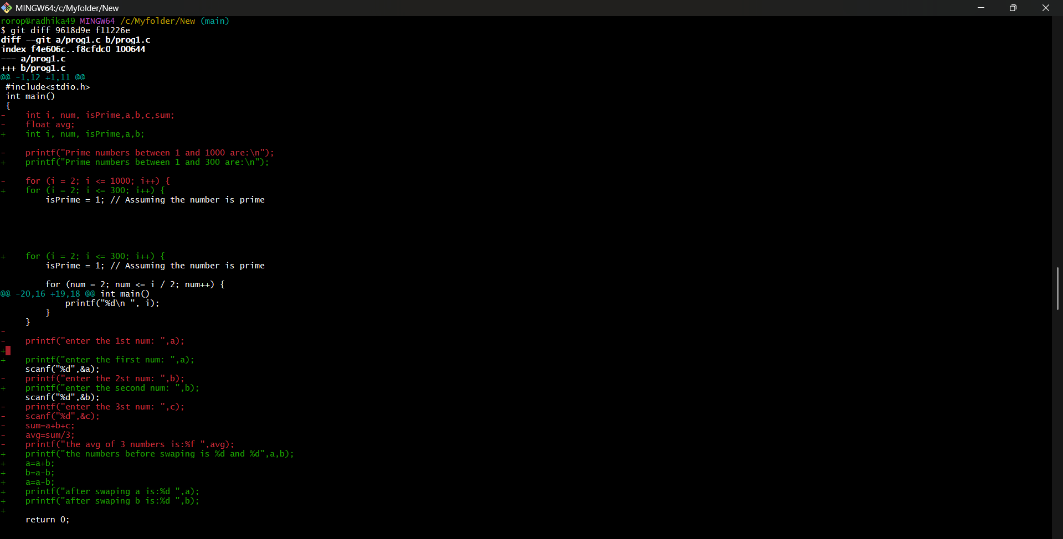

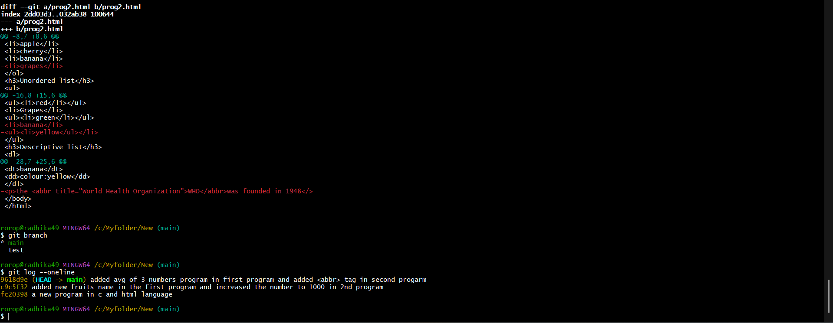

* git branch<branch name> will create a new branch
* git checkout<branch name> will switch to that respective branch

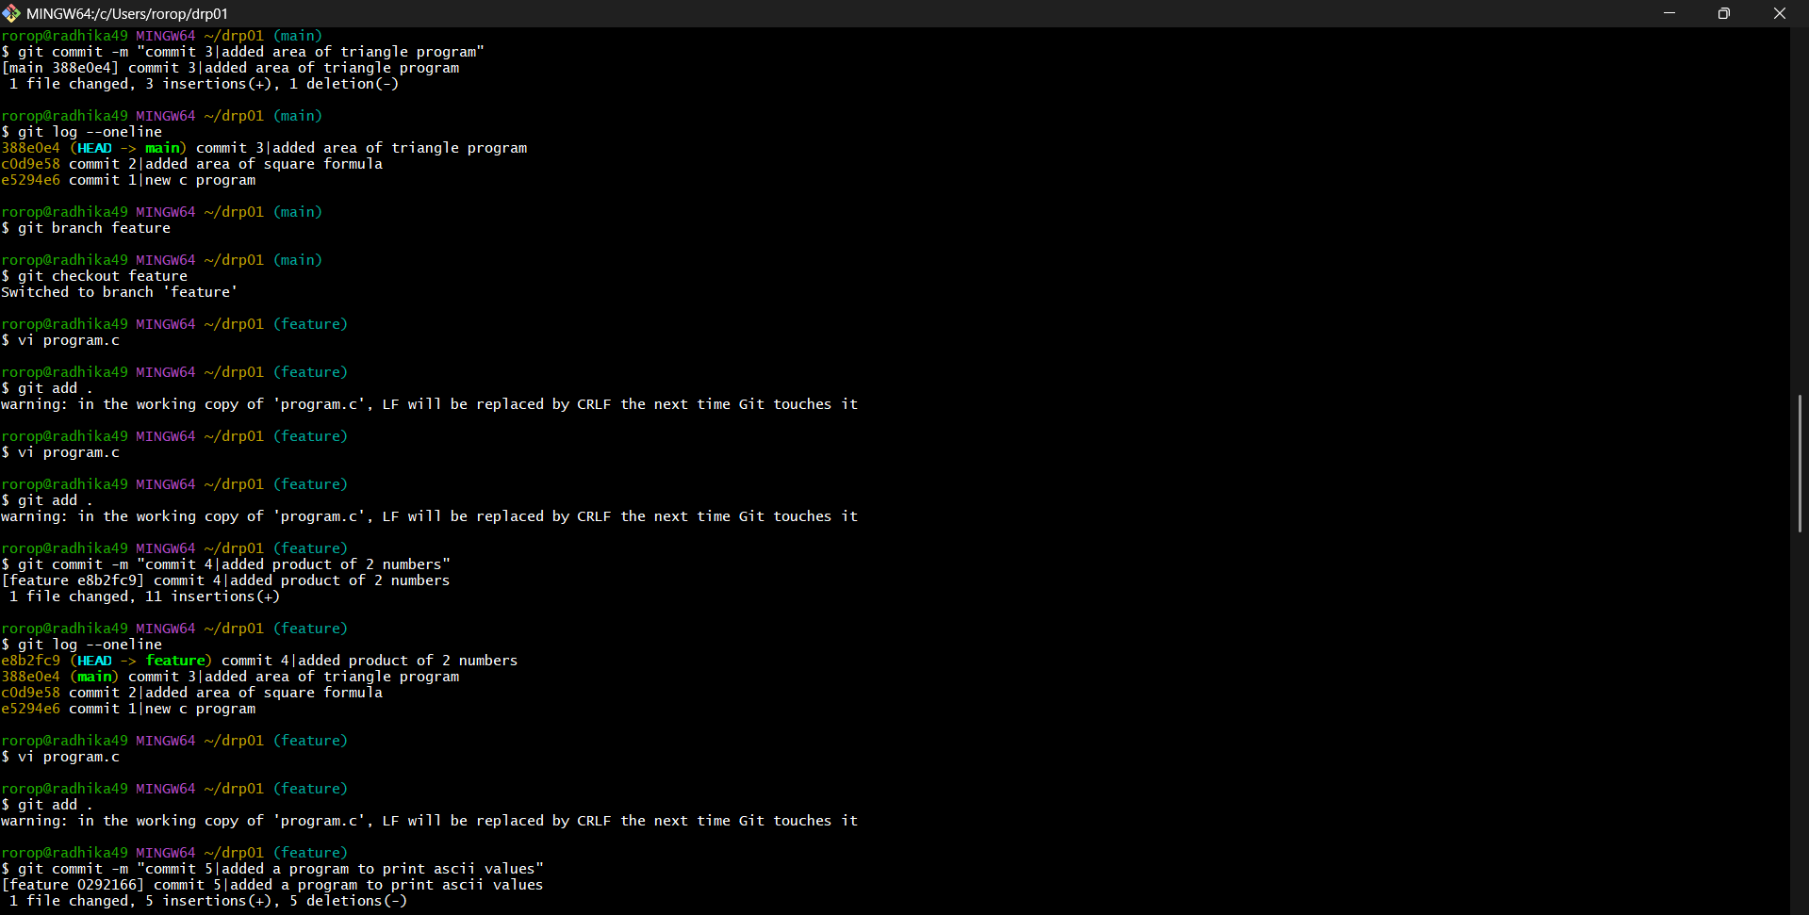

* git merge <branch name> will merge the branch with the main branch.

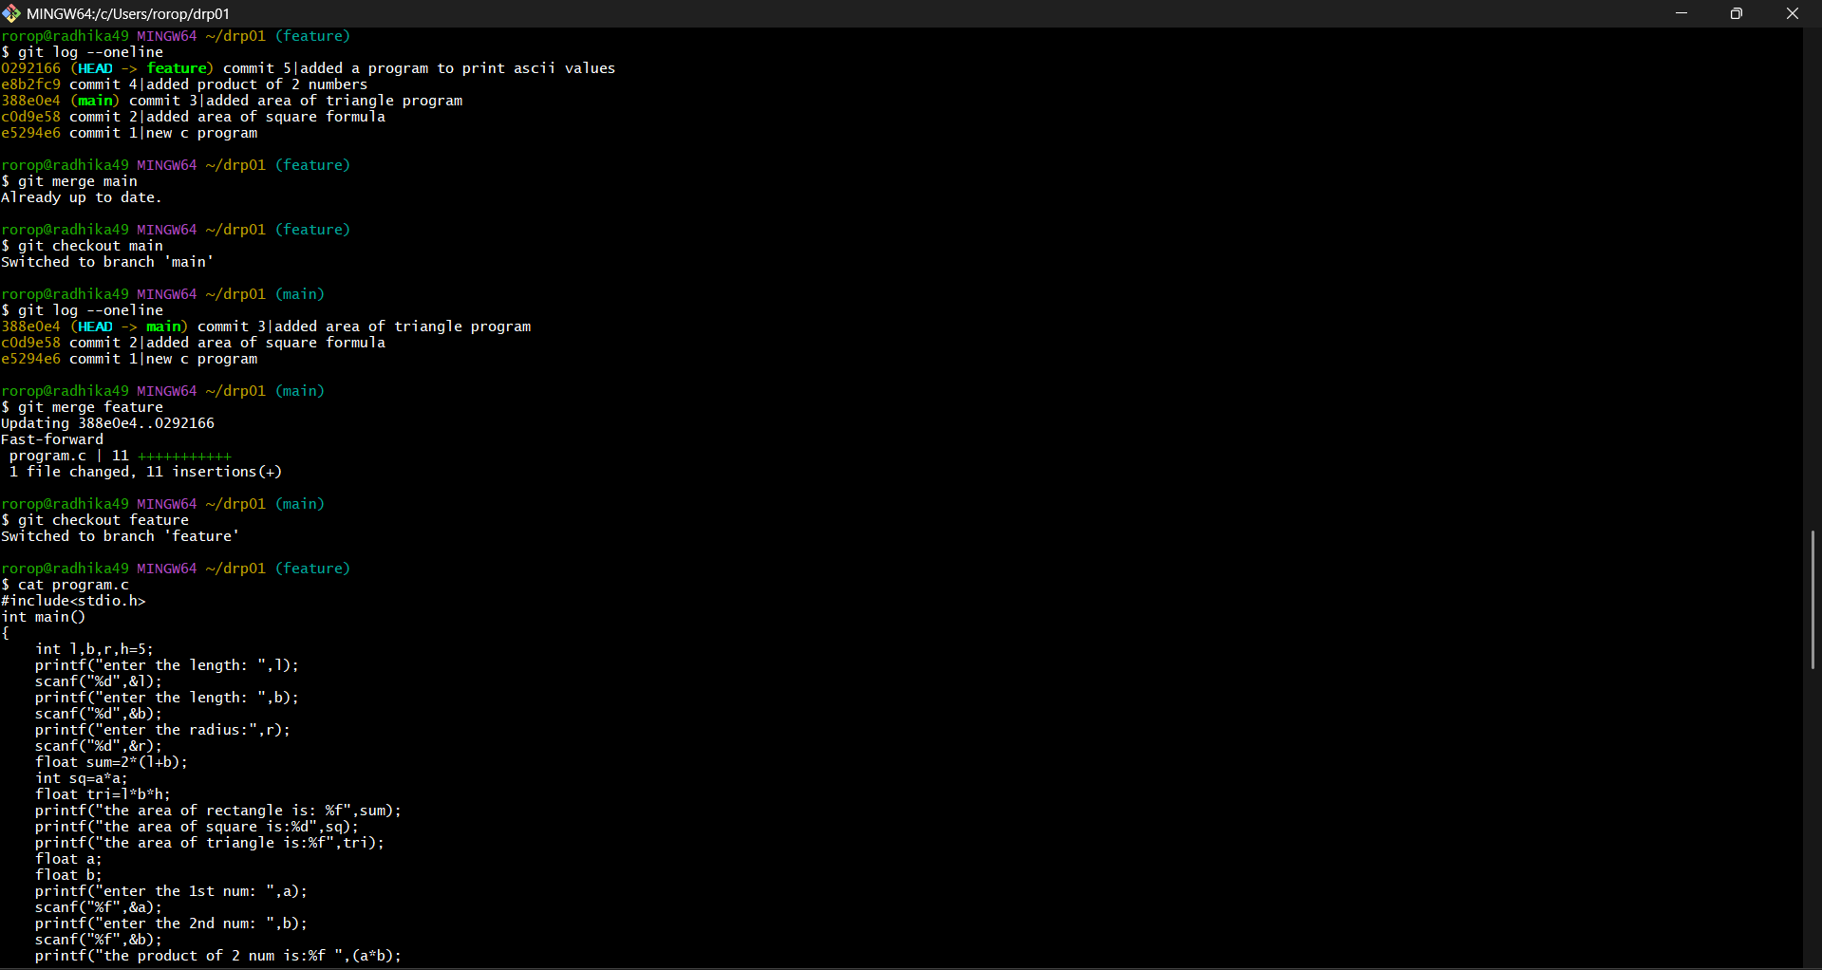

**Source Code Management - Project**

The project is make branch’s add files and commit in those branch’s and later merge it with the main branch.

Later, forking cloning and merging the repositories of the teammates

* Creating directory.

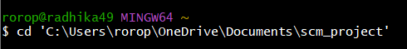

* Initializing the directory.



* Creating branch’s.

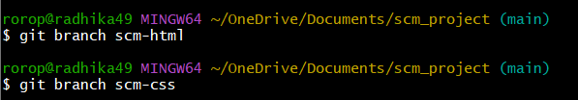

* Creating a readme file.

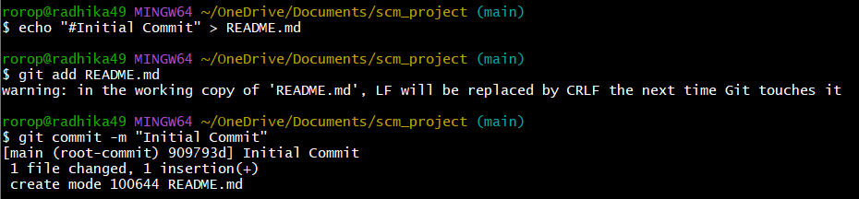

* Go to the new branch add file, write the code, add git add the file

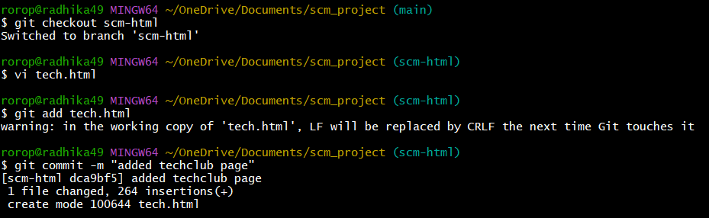

* Go to the same file make changes and commit the changes.

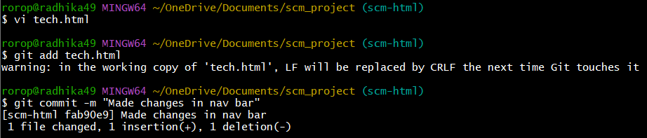

* Go to another new branch add the file, write the code and git add the file.

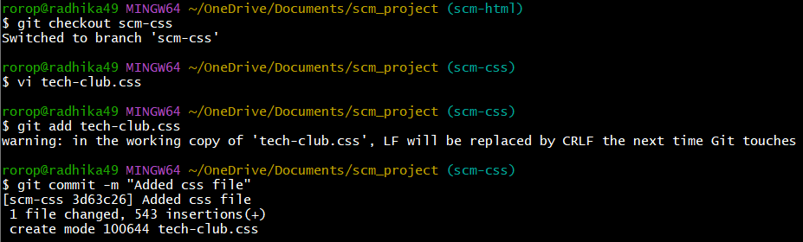

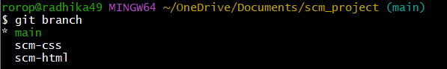

* Later merge both the branch’s with the main branch.

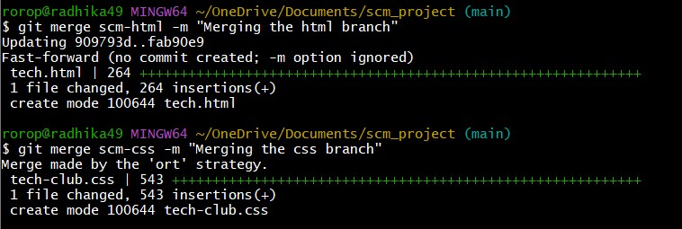

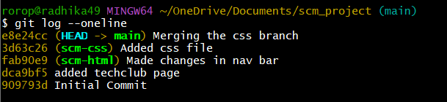

* Git remote add the repository.

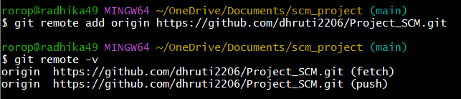

* Push the main branch to the GitHub.

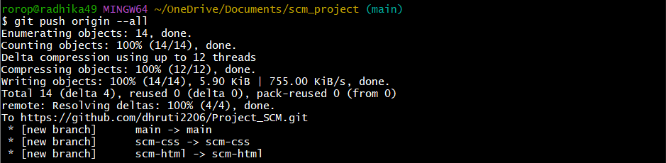

* Contributing in my teammates repository
* Forking, cloning and pushing of Meenaamrutha’s repo

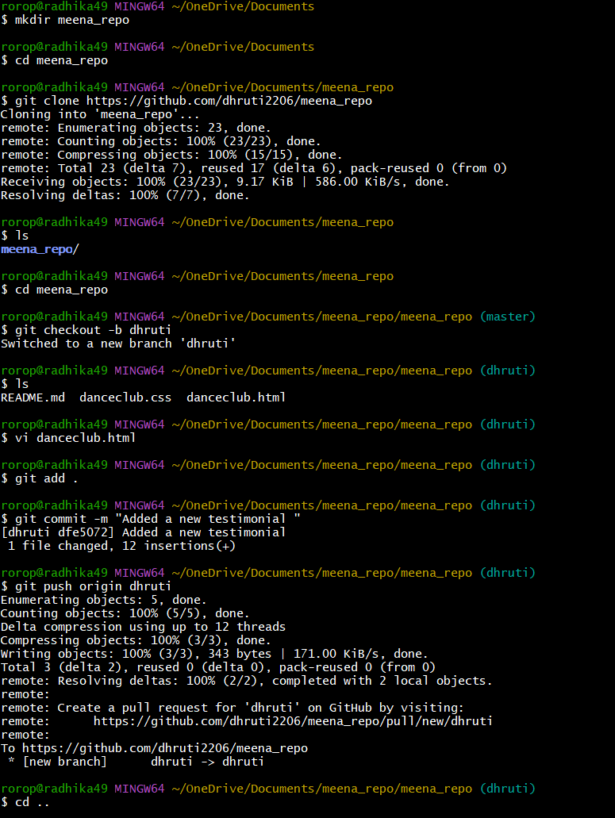

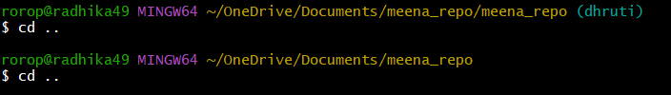

* Forking, cloning and pushing Rohith’s repo

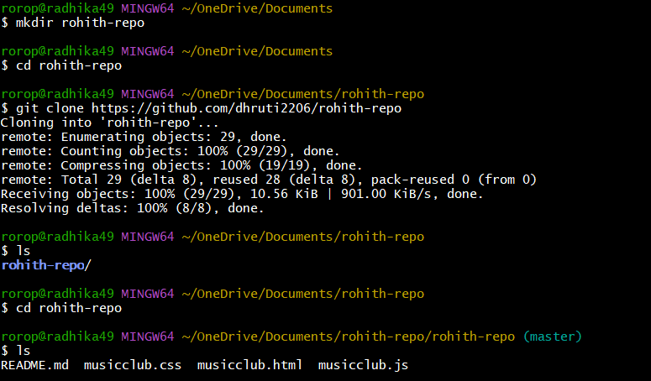

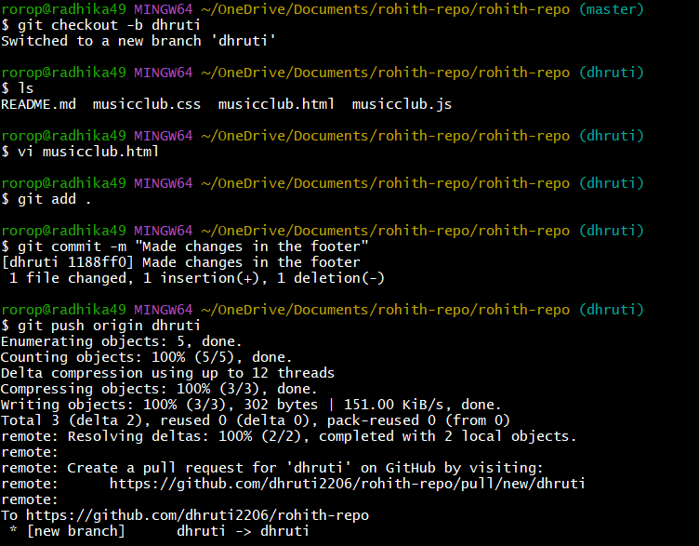

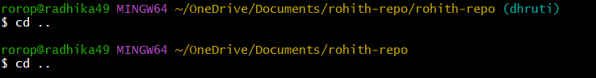

* Forking, cloning and pushing of Bhargav’s repo

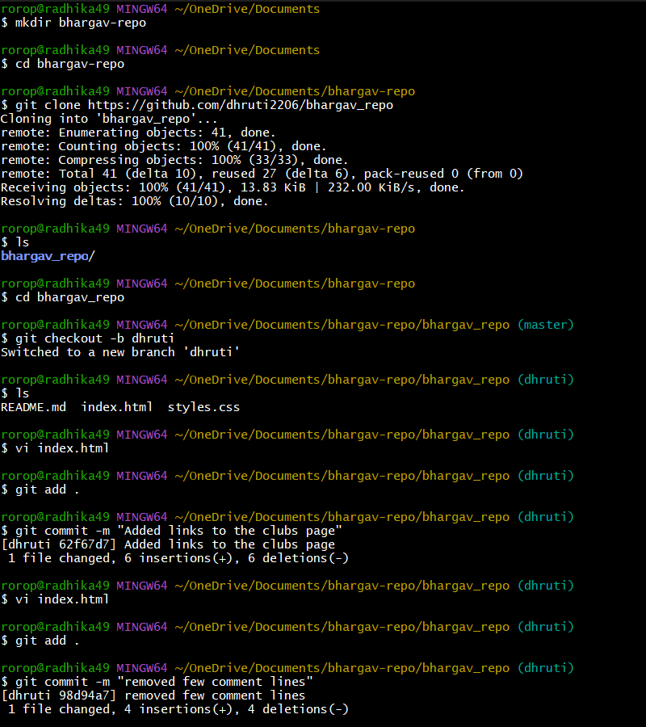

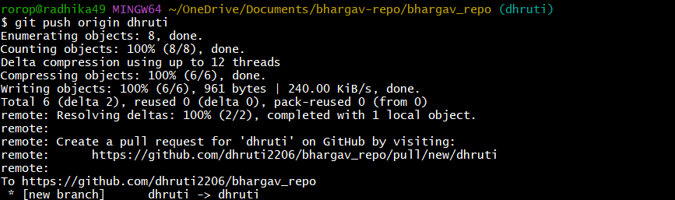

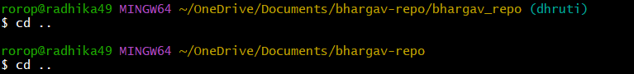

* Forking, cloning and pushing of Chethan’s repo

